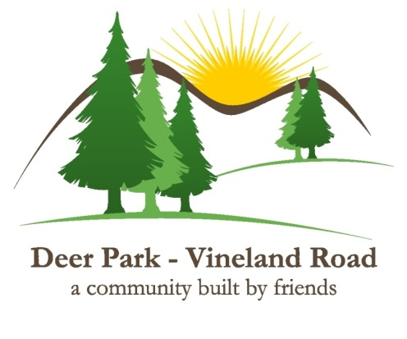
Deer Park Vineland Road Local Service District
530 Salmonier Line
Holyrood, NL
A0A 2R0

LSD Meeting Minutes
June 3, 2026
7.00pm
Matthew Daley’s cabin

In Attendance:
Dave Chaulk
David Hiscock
Jim Buckingham
Kevin O’Regan
Charlie Noseworthy
Matthew Daley
Corey Butler

Call to Order
Dave Chaulk called the meeting to order at 7:01pm

Confirmation of Quorum
Dave Chaulk confirmed Quorum was met with the full committee in attendance

Call for New Business
Invoices in Arrears was a requested item by David Hiscock

Acceptance of minutes: April 16, 2026
Copies of the last meeting minutes were circulated. Kevin O'Regan thanked David Hiscock for completing them and made a motion to accept the minutes as presented. Seconded by Matthew Daley. A vote was taken and the motion passed.

Financial Update

Fee Collection:
Fee collections have been going well with about 29 properties still outstanding. The current fee structure appears to be working well, with an incentive for early payment and charges for late payment.

Legal Action
The LSD has taken formal legal action against a property owner who owes fees for multiple years and refuses to respond to payment requests from the committee. A Statement of Claim with The Provincial Court of Newfoundland has been served on the owner. The LSD is in the process of initiating action on other delinquent owners. Were owners refuse to pay the fees due, the LSD intends to use any avenues available through the Court system to recover outstanding fees and collection costs.

.2….

The LSD is in good financial condition and has the ability to do significant road work in the 2026 season.

There was discussion on the current balance of the contingency fund, and its adequateness given the recent rise in equipment operation costs as well as our province’s 2025 disaster experiences related to both damage from forest fires and extensive flooding.

Jim Buckingham made a motion that $ 10,000 be taken from the operating funds and place in the contingency fund by way of a cashable GIC. Like the current certificates, this additional fund can only be used in case of emergency and will require a vote of the committee. The goal will be to raise the total fund to $100,000 when possible. The motion was seconded by Charlie Noseworthy. A vote was taken and the motion carried.

Roads Update

Dave Chaulk thanked committee members Jim Buckingham and Matthew Daley who participated in the survey of the road work required this season with the contractor. Matthew Daley made a motion to proceed with the work as defined, seconded by David Hiscock. A vote was taken and the Motion carried.

Charlie Noseworthy and Corey Butler will connect with the contractor to survey the balance of the LSD so a complete plan of roadwork can be finalized.

There has been some grading activity and touch up work completed already. In several areas, there is a plan to narrow the road in areas that grading and fill over the years has pushed to road to widen it. These areas are a source for both fill and class A that can be removed and placed in areas requiring more material.

Jim Buckingham has acquired some hazard marker signs and donated the to the LSD, they will be placed in areas where caution is required in narrow sections of the road.

Emergency Procedures Plan update

This to be presented in a future meeting.

Outdoor Fire Regulations for deer park/Vineland Road

Dave Chaulk is going to have suitable warnings and caution notices placed on the website.

Municipal Capital Works Project culvert update / cancelling any costs
David Hiscock discussed this project. While there is an opportunity for cost sharing of significant projects, the work required to manage this project by a volunteer committee makes the activity unfeasible.
Matthew Daley made a motion to cancel any further work on this project. Seconded by David Hiscock, A vote was taken and the motion carried.

.3…

Civic Numbering 911

Dave Chaulk is making headway with this project with Municipal Affairs concerning updates with Google Maps, and noted that there are three departments involved. He plans to have the maps as completed forwarded in the coming weeks.

AGM date Summer Sunday – Salmonier Nature Park
Kevin O’Regan has reached out to The Salmonier Nature Park, they do have space and are willing to host our AGM, they would prefer a Sunday date. It was discussed that it may be worthwhile to try holding the AGM in the area again, the last attempt could not produce a quorum, and the meeting has been held in St. John’s since then. Several dates were suggested, Kevin to follow up.

New Business
David Hiscock wished to discuss ‘Invoice in Arrears’, owners who refuse to pay fees and require legal action. This collection presents both a cost and a use of time resources to the LSD. It is recognized that the funds spent by the LSD enhance the value of these properties, even thought the owners do not pay for it.
There was also the issue of owners either subdividing to sell or selling property that is not registered in the LSD.
This was certainly accepted as a concern, but more work is required to analyze the issue.

Adjournment

David Hiscock made a motion at 8:40pm to adjourn the meeting. Seconded by Charlie Noseworthy. A vote was taken and the motion carried

