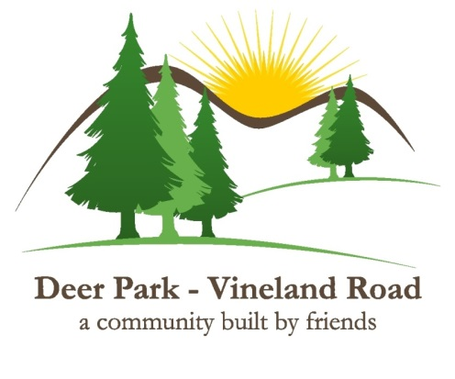**Deer Park Vineland Road Local Service District**

**530 Salmonier Line**

**Holyrood, NL**

**A0A 2R0**

**DP/VR LSD Committee Meeting Agenda**

**May 1,2024 7:00pm**

**Via Zoom**

Present:

Dave Chaulk

David Hiscock

Matthey Daley

Terry Penney

Kevin O’Regan

Regrets

Corey Butler

**Call to Order of Meeting**

Dave Chaulk called the meeting to order at 7:04pm and declared a quorum present

**Confirmation**

Davin Hiscock made a motion to approve that the meeting be conducted electronically by all members. Seconded by Matthew Daley. A vote was taken and the motion carried.

Project One

David Hiscock made the following motion:

* Be it resolved that we, the Ultimate Recipient - Deer Park- Vineland Road Local Service District -accept cost-shared funding as outlined in the Department of Transportation and Infrastructure project approval letter dated 27 March 2024, Project Number 17-MCW-24-00027, Culvert Replacement/Upgrade #1, with a total project value of $ $14,763. This committee agrees to provide the Ultimate Recipient share value of $6,694 in funding for this project and authorizes the Committee Chair and Committee Treasurer to enter into a funding agreement with the Department of Transportation and Infrastructure on behalf of the Deer Park-Vineland Road Local Service District.

Seconded by Terry Penney. A Vote was taken and the motion carried.

Project Two

David Hiscock made the following motion:

* Be it resolved that we, the Ultimate Recipient - Deer Park- Vineland Road Local Service District -accept cost-shared funding as outlined in the Department of Transportation and Infrastructure project approval letter dated 27 March 2024, Project Number 17-MCW-24-00027, Culvert Replacement/Upgrade #2, with a total project value of $ $14,763. This committee agrees to provide the Ultimate Recipient share value of $6,694 in funding for this project and authorizes the Committee Chair and Committee Treasurer to enter into a funding agreement with the Department of Transportation and Infrastructure on behalf of the Deer Park-Vineland Road Local Service District.

Seconded by Kevin O’Regan. A Vote was taken and the motion carried.

Project Three

David Hiscock made the following motion:

* Be it resolved that we, the Ultimate Recipient - Deer Park- Vineland Road Local Service District -accept cost-shared funding as outlined in the Department of Transportation and Infrastructure project approval letter dated 27 March 2024, Project Number 17-MCW-24-00027, Culvert Replacement/Upgrade #3, with a total project value of $ $14,763. This committee agrees to provide the Ultimate Recipient share value of $6,694 in funding for this project and authorizes the Committee Chair and Committee Treasurer to enter into a funding agreement with the Department of Transportation and Infrastructure on behalf of the Deer Park-Vineland Road Local Service District.

Seconded by Matthew Daley . A Vote was taken and the motion carried.

**Adjournment**

David Hiscock made a motion to adjourn the meeting T 7:15PM . Seconded by Terry Penney. Avote was taken and the motion carried.